**Q1: GitHub**

<https://github.com/Carciax/EEE3088F-Project-CKR>

**Q2: Power Subsystem Failure Management**

i) I am going to put 0 ohm resistors over each component so that we can use the available connections points to bypass any broken components. I have put pins to connect an external 3V3 power source.

ii) I will ensure to use the correct size to the appropriate current rating for each track to protect against track damage.

I will also make the ground track thick.

iii) I will provide other options to replace components or go and buy the components from other shops and solder them on. I will also ensure to use components with large quantities of stock decreasing the chance of the component running out.

iv) I will make the circuit as modular as possible allowing for changes to the circuit as well as providing lots of available connection points to make modifications post PCB development.

**Q3: Sensing Subsystem Failure Management**

Each I/O trace will be connected to two separate pins on the microcontroller. Each trace will have a 0Ω resistor between the sensor pin and the microcontroller pin, but one of these 0Ω resistors will be DNP. This will allow a different microcontroller pin to be used in the event that one fails. These connections are shown on the microcontroller schematic.

The l main power line will also be populated with a 0Ω, to allow the entire module to be disconnected from power in the instance that a design error and/or circuit damage within the sensor module leads to a short.

If the 0Ω resistors have to be de-soldered, their pads can be used to solder a wire directly to another pin on the microcontroller.

Finally, the design includes 2 analogue sensors (a potentiometer which can be connected to some small mechanical device, and a thermistor), and 2 digital sensors (an ambient light sensor and a temperature/humidity sensor). Best case scenario, this means that the HAT is multi-faceted and can serve a variety of different research purposes. However, in the event of of component/design failure or inadequate component stock, the HAT will hopefully still have other functioning sensors and thus will still be useful. It is specifically useful that there are 2 different temperature sensors, given that our original examination of use cases for the HAT placed on a strong emphasis on the HAT’s ability to sense temperature.

**Q4: Microcontroller Subsystem Failure Management**

For individual component failure, components will be connected into the circuit by some means that it can be disconnected. Components that are likely to fail will get jumpers which can be easily remove and another component can be connected from an external board.

Components that are less likely to fail will get two pads soldered together in line with the component. These can easily be soldered and de-soldered, and the signal can be measured in that line. Lastly, components that are likely never going to fail will get 0Ω resistors which can be taken out and/or rerouted to other lines.

**Power and controls:**

The power and ground of the microcontroller has solder pads in place to ensure that the microcontroller can function without the power and sensors. The debugger input is already a pin header and thus can be plugged – which also means that the NSRT reset pin has a pin header that can be easily accessed to reset the microcontroller. There are enough redundant push buttons that failure management is unnecessary. The BOOT0 or boot mode pin has a solder pad in case the board needs to be booted in a different mode.

**Sensors and EEPROM:**

The digital sensors inputs and the EEPROM communication lines have 0Ω resistor pairs in place such that they can change between I2C1 and I2C2 communication protocol, and so that there are a pair of lines available for isolated testing of components. The analogue sensors have 0Ω resistor pairs such that they can change between GPIOA and GPIOB reading the value.

**Output:**

The output USB has a 3 pin header on both Tx and Rx lines such that the USB can be changed between UART1 and UART2 as well as the board can communicate with an external USB setup in case the onboard USB port or differential pair lines to UART chip are damaged. The LED has also been wired with a jumper such that an output signal can be jumped to an external board.

This system of failure management allows for most components to be isolated for testing, redirected in case of line damage, or have signals inputted or outputted to an external board for testing.

**Q5: Power Subsystem Schematic**

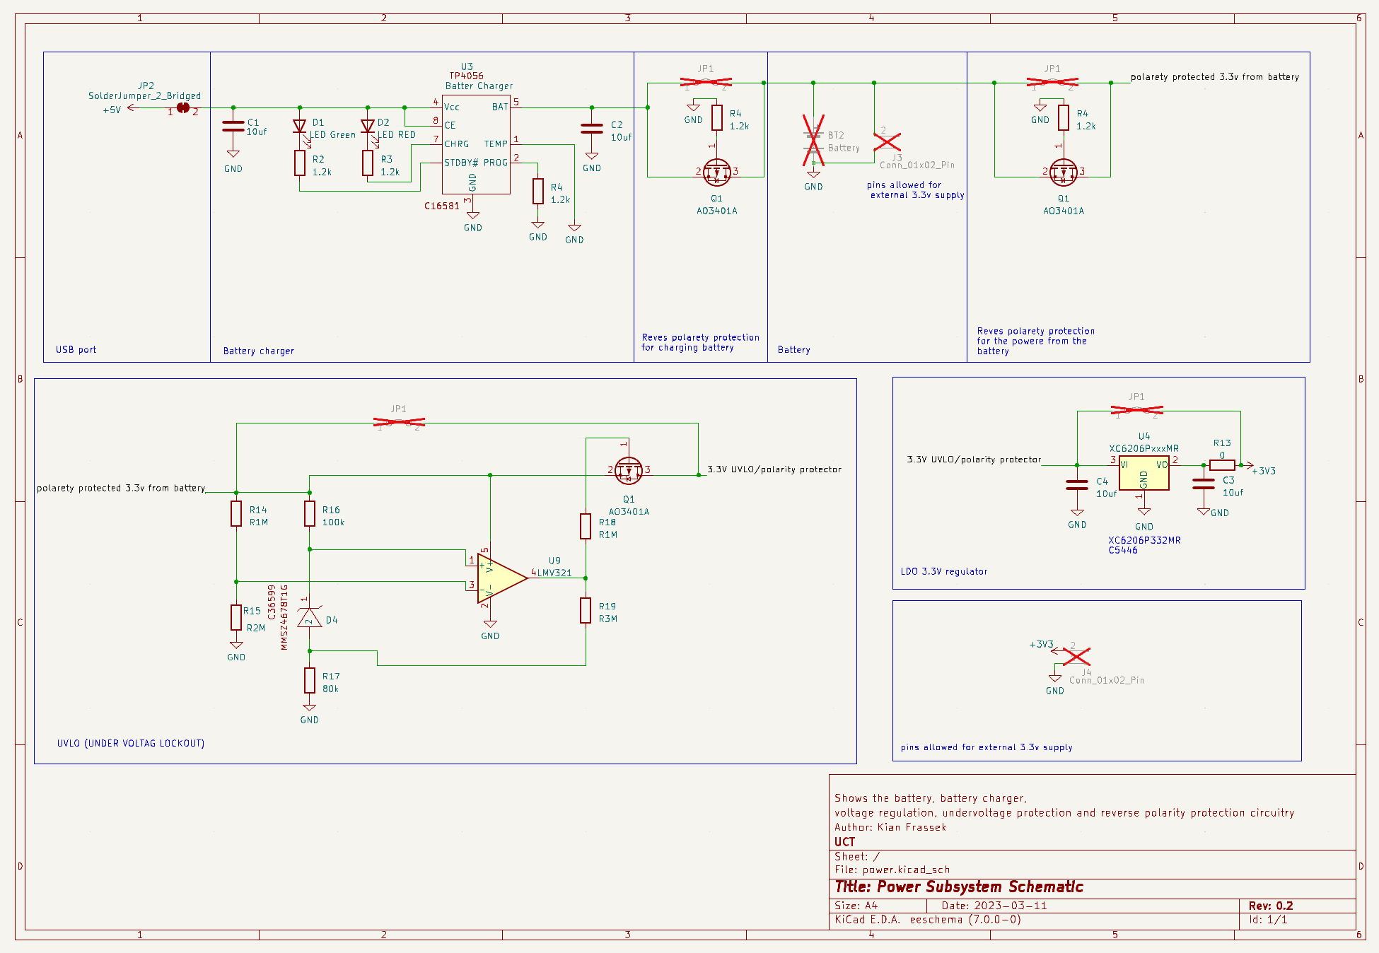

**Q6: Sensing Subsystem Schematic**

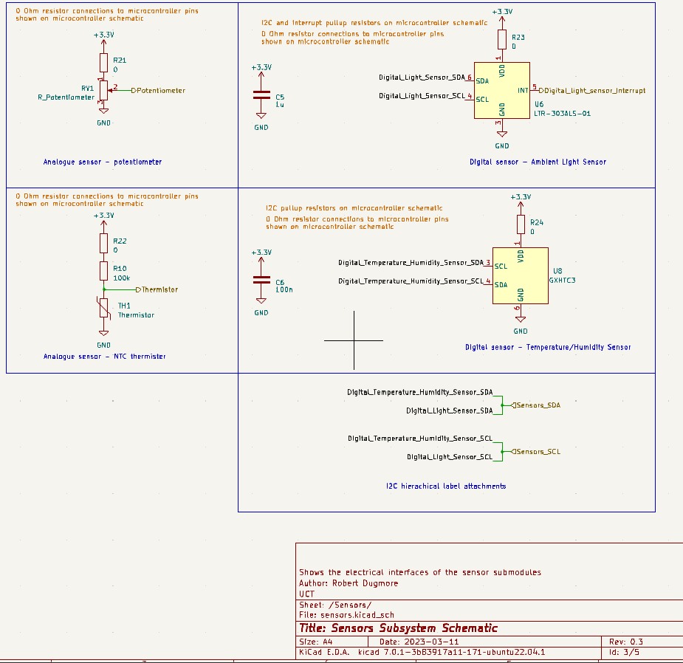

**Q7: Microcontroller Subsystem Schematic**

The microcontroller schematic

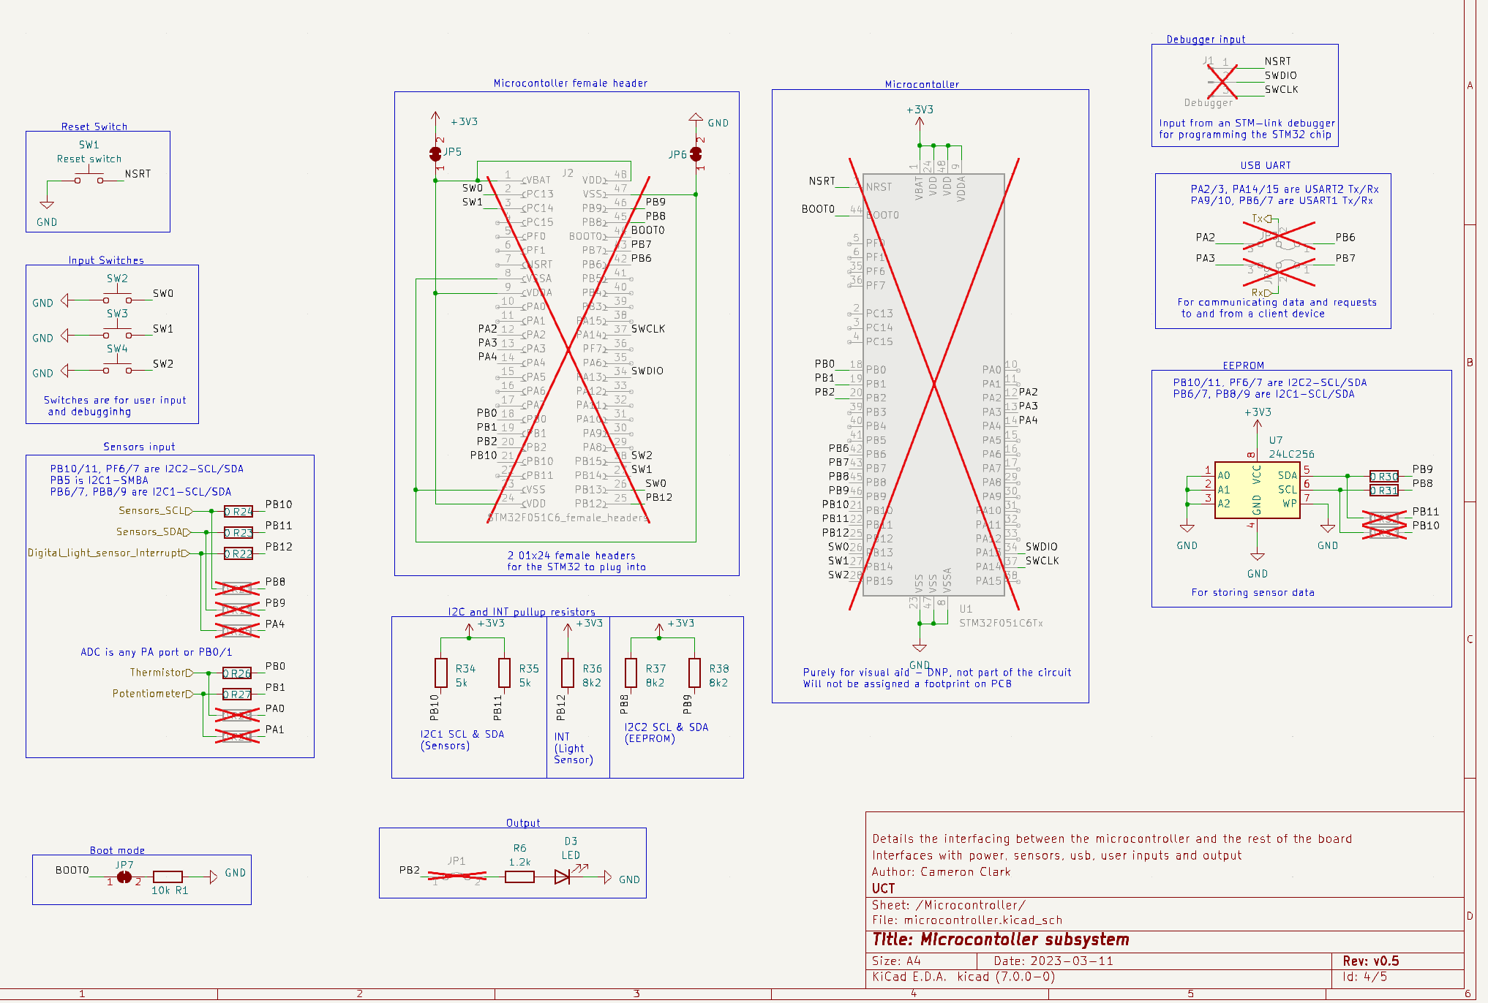

The USB input schematic

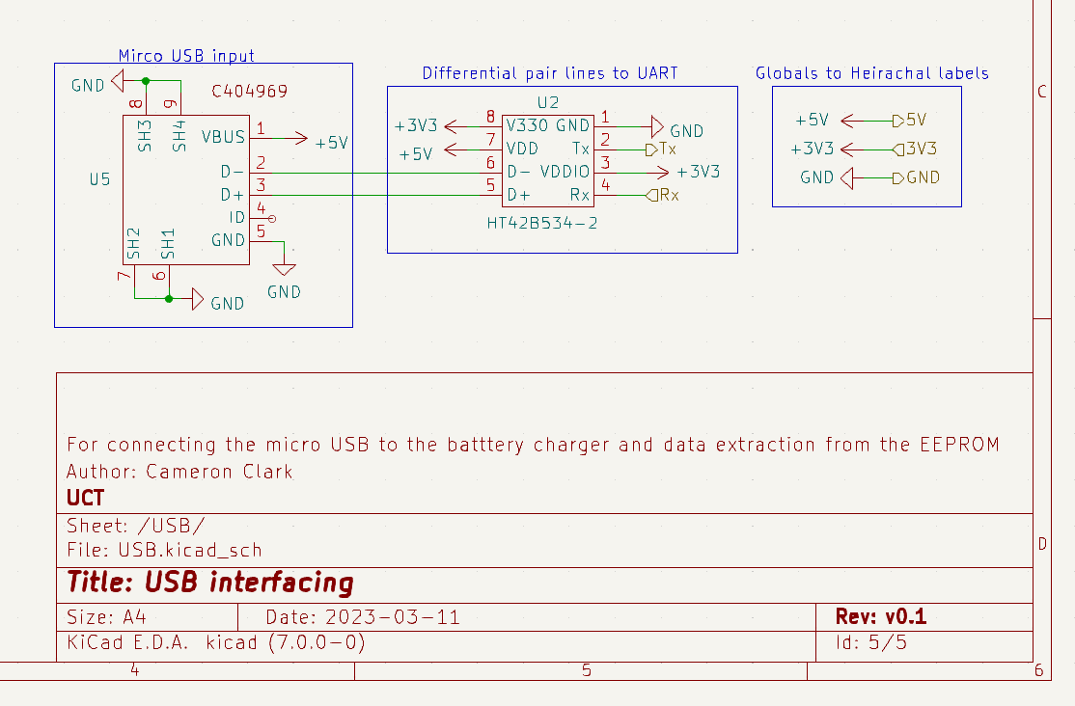

**Q8: Planned ERCs**

* Make sure the 5V and 3V3 and GND labels aren’t short circuit to each other.
* Make sure there are no floating pins.
* Make sure the power running through resistor doesn’t exceed their maximums.
* Make sure power lines do not go through traces that are too thin.
* Perform the ERC on KiCad.
* Follow all the rules on JCL components specification for board design.

**Q9: Updated BOM**

https://github.com/Carciax/EEE3088F-Project-CKR/blob/main/Budgeting/Budgeting.xlsx